Transducers for M8

 | Probe | Illustration | Parameters | Application | Biopsy kit
Convex | C5-1s | 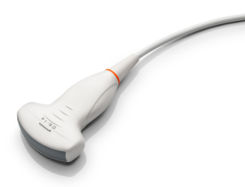 | Bandwidth: 1.3-5.7 MHz  ExFOV: 101°  Radius: 60mm | Adult Abdomen  Gynecology Obstetrics | NGB-022,  multi angle,  reusable
 | C6-2Gs | 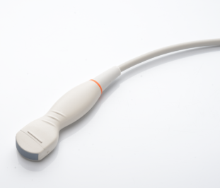 | Bandwidth:1.7-6 MHz  ExFOV:132°  Radius:20mm | Interventional | NGB-024, multi angle,  reusable
 | D7-2s | 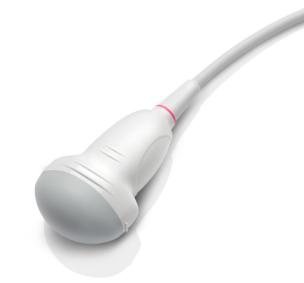 | Bandwidth: 1.6-7.2 MHz  FOV:  71° X 70°(sweep) | Obstetrics | None
Micro-convex | C11-3s | 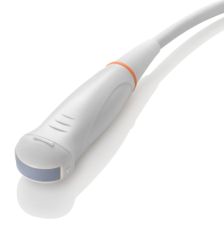 | Bandwidth:3-11.2 MHz  ExFOV: 121°  Radius: 15mm | Abdomen  Pediatrics Transcranial  Vascular  Small parts  Musculoskeletal | NGB-018,  multi angle,  reusable
Endocavity | V11-3Ws | 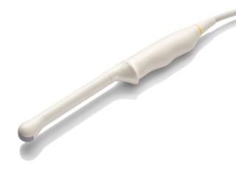 | Bandwidth:3-11.2 MHz  ExFOV: 180°  Radius: 11mm | Gynecology  Obstetrics  Urology | NGB-004,  single angle,  reusable
Linear | L10-3s | 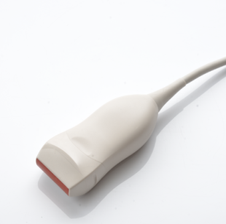 | Bandwidth:2.7-10.5 MHz  FOV:34mm | Vascular  Small parts  Musculoskeletal  Nerve | Not available
 | L13-3s | 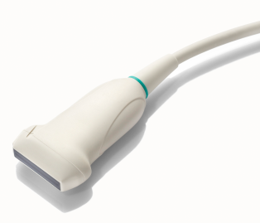 | Bandwidth: 3.2-12.3MHz  FOV: 37.9 mm | Small parts  Vascular  Pediatrics  Superficial  Musculoskeletal Neurology  Abdomen | NGB-007,  multi angle,  reusable
 | L14-6Ns |  | Bandwidth:3.5-16 MHz  FOV:38mm | Small parts  Vascular  Pediatrics  Superficial Musculoskeletal Neurology | NGB-007,  multi angle,  reusable
 | L16-4Hs | 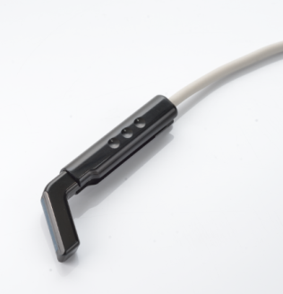 | Bandwidth:3.5-16 MHz  FOV:25mm | Musculoskeletal  Nerve  Intra-operative  Vascular Surgery | Not available
 | LM14-6s  (Matrix) | 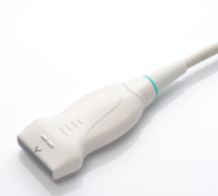 | Bandwidth:3.5-16 MHz  FOV:38mm | Small parts  Musculoskeletal  Nerve | NGB-023, multi angle,  reusable
 | L14-6Ws | 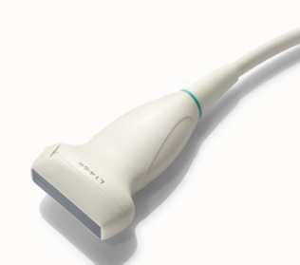 | Bandwidth:3.5-16 MHz  FOV:50mm | Breast  Small parts  Musculoskeletal  Nerve | NGB-007, multi angle,  reusable
 | L20-5s | 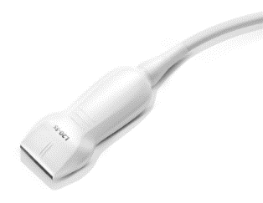 | Bandwidth:  6-23 MHz  FOV: 29mm | Musculoskeletal | None
Sector | P4-2s |  | Bandwidth: 1.3-4.7 MHz  FOV:90° | Adult Cardiac  Transcranial  Adult Abdomen | NGB-011,  multi angle,  reusable
 | P10-4s  (High Density) | 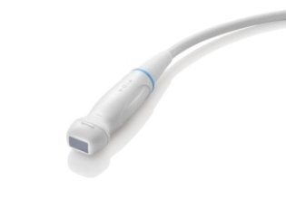 | Bandwidth:2.9-10.5 MHz  FOV: 90° | Neonatal Cardiac  Transcranial | Not available
 | P7-3s |  | Bandwidth:2-8 MHz  FOV: 90° | Pediatric abdomen Pediatric cardiac Neonatal cephalic Neonatal abdomen Neonatal cardiac | Not available
TEE | P7-3Ts | 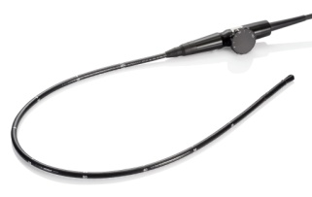 | Bandwidth:1.9-8.2MHz  FOV:90° | Adult cardiac | Not available
 | CW2s | 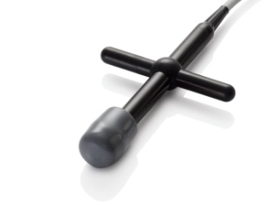 | Bandwidth: 2MHz | Cardiac | Not available
 | CW5s | 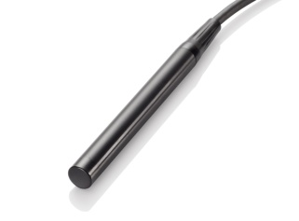 | Bandwidth: 5MHz | Vascular | Not available

